Cardle Proposal

Rene-Henri Croteau, Thomas Lemay, Eric Picard

**Project Description:** Our Cardle app is an original game about cars. The game will have multiple game modes related to cars. One of them (Classic cars) is guessing the car with images, each time you get it wrong images get easier. To win in Classic Cars you need to guess the right amount of cars right. The second one is (Classic brands), its the same thing as the game mode named (classic cars) but instead of guessing cars you are guessing brands. Higher or Lower is the third game mode, you will be presented with 2 cars and need to guess which is pricier, when you fail you lose the game.There will be around 5 game modes and all have different categories and difficulty. We also plan to have a daily streak. The daily streak will have the classic game mode (the image guessing getting progressively easier). The leaderboard part would be divided for each game mode and have a daily streak section. We will also have a currency in the game. Each time you win or complete daily challenges you will earn coins. With the coins, you will be able to get hints if you are stuck in a game no matter what game mode.

**Wireframes:**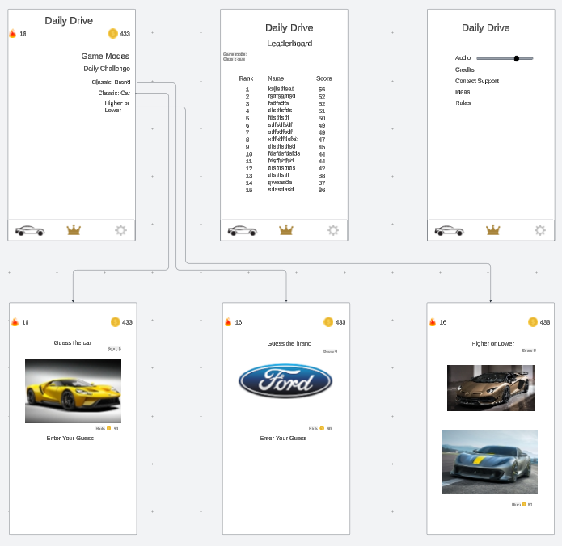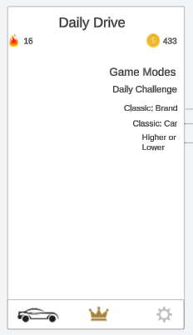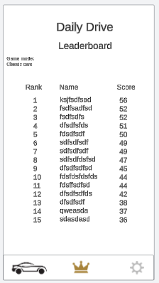

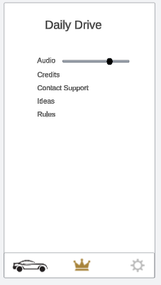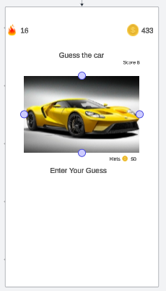

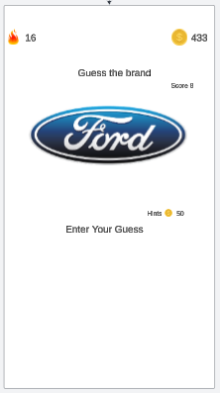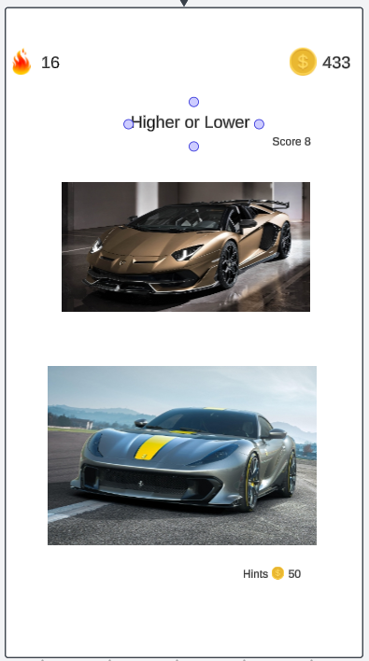

**Complexity Requirement:**

The application will have a local memory cache and communicate with a web server and a web API for a better user experience. We plan to include a leaderboard with user data and high scores to make our game a little competitive and more fun for the players. For this leaderboard, we’ll use an SQL database to store information and images. We also plan to have a daily streak. The daily streak would communicate with the web API to have the current hours of the day.